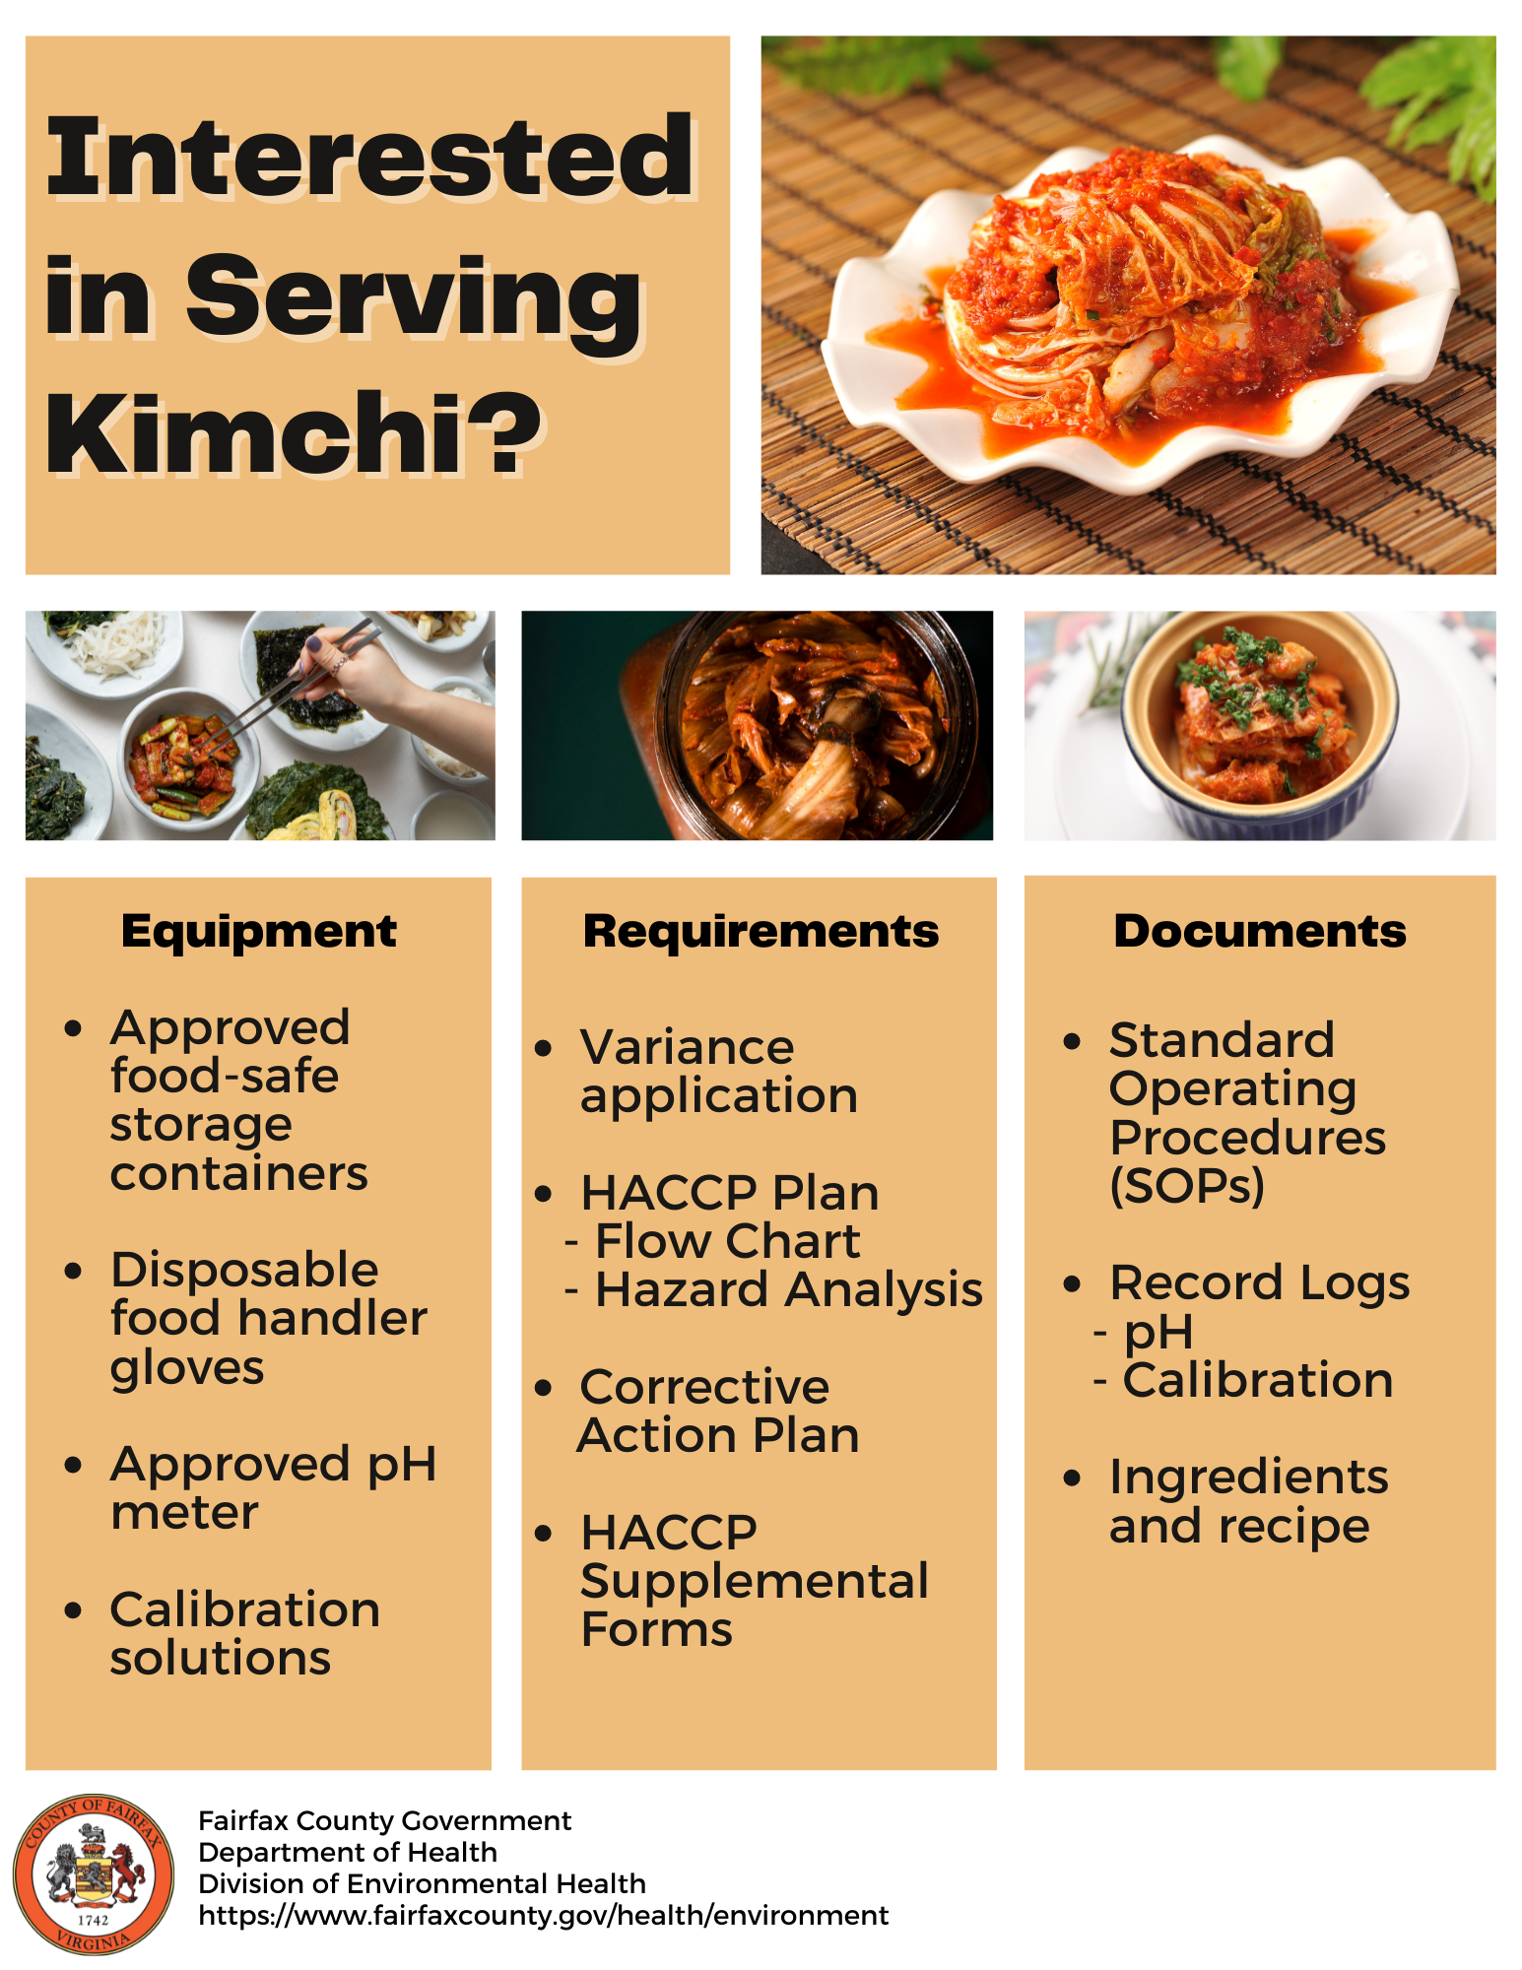

Standard Operating Procedures (SOPs) – Kimchi
Following standardized, written procedures with a SOP for performing tasks ensures that quality, efficiency, and safety criteria are met each time the task is performed.
Source | All kimchi ingredients should be obtained from an approved food source (e.g. licensed vendors or stores.) Do not use food that has been prepared and stored in a private home.
Receipt | Visually inspect kimchi ingredients for blemishes or potential contaminants upon receipt. Temperature Control for Safety (TCS) foods must be received at a temperature of 41F or below. Food packages shall be in good condition and protect the integrity of the contents.
Storage (Cold & Dry) | Food shall be protected from contamination by storing the food in a clean, dry location where it is not exposed to splash, dust, or other contamination and at least 6 inches above the floor. Food shall also be protected from cross contamination by separating raw animal foods and vegetables before they are washed. Throughout the entire process, food shall also be stored in safe, durable, corrosion resistant, approved food contact equipment that may withstand repeated warewashing.
Cleaning & Sanitizing | All food contact surfaces, equipment, and utensils used for kimchi preparation shall be clean to sight and touch, properly sanitized, and stored to prevent contamination. Proper sanitization involves washing, rinsing, and sanitizing equipment with sanitizer solutions at the proper concentration and for proper exposure times. Sanitization using heat may also occur, with an irreversible registering temperature indicator demonstrating surface temperature of 160F for equipment or utensils being sanitized. Surfaces, equipment, and utensils should air-dry prior to use.
Cutting, Slicing & Shredding | Raw vegetables shall be thoroughly washed in water to remove soil and other contaminants before being cut and combined with other ingredients. Chemicals used in the washing of vegetables shall be used in accordance with manufacturer instructions. During preparation, food shall be protected from all sources of contamination. Food employees shall wear gloves while handling ready-to-eat foods. During pauses of food preparation, utensils shall be stored in a manner free of contamination.
Labeling | Label each batch of kimchi with a unique identifier so that its pH may be tracked. Document the identifier in the acidification log.
Salting Phase | Add salt to vegetables for fermentation. Food shall be protected from contamination by storing the food in a clean, dry location where it is not exposed to splash, dust, or other contamination and at least 6 inches above the floor.
Rinse & Drain | Rinse the vegetables to remove excess salt, using clean and sanitized equipment and/or in a clean and sanitized basin of a food preparation sink. Ensure clean hands while preparing food and don gloves if using hands to handle ingredients.
Add Ingredients & Mix | Place gloves on clean hands or use clean utensils to combine kimchi ingredients. Preparation area shall be free of potential sources of contamination.
Continued Fermentation | Calibrate the pH meter before each use and log the calibration results. Test kimchi pH to determinate adequate fermentation of 4.2 or below and document the pH on the acidification log. During fermentation, food shall be protected from contamination by storing the food in a clean, dry location where it is not exposed to splash, dirt, or other contamination and be at least 6 inches above the floor. Trash cans and trash bags are not approved for use for food storage.
Final Product Storage | Food must be stored in a clean, dry location free of exposure to contamination. Food must be stored at least 6 inches above the floor. During pauses in food preparation or dispensing, utensils shall be stored with their handles above the top of the food.
Service | Dispensing utensils shall be sanitized before use after cleaning and each time there is potential contamination.
Train Personnel | All staff responsible for making kimchi shall be trained on preparation processes and documentation requirements. Staff shall be trained on the following practices: how to properly prepare and handle kimchi, when and how to utilize a pH meter to monitor pH, documentation and labeling requirements, cleaning and sanitization of food contact surfaces, equipment and utensils, employee illnesses and disease, and employee handwashing, hygiene, and glove use.
Corrective Action: Food contaminated by employees, consumers, or other persons through contact with hands, bodily discharge, or other means shall be discarded. Also, if pH is above 4.2, continue the fermentation process.
Kimchi Fermentation HACCP Flow Guidance
Ingredient Receiving
Confirm food is received from an approved source. Ensure receiving temperatures are ≤41F for TCS foods
Storage
List where TCS food and non-TCS food are stored. Ensure TCS foods are stored ≤41F
Fermentation
List locations and timing of fermentation
Labeling/Start Log
Label each batch and record start date and unique identifier on log
Preparation Steps
List steps needed (i.e. washing, weighing, chopping, salting, rinsing, mixing etc.)
pH Determination (CCP)
Final pH of ≤ 4.2
Maintain product pH logs and pH meter calibration records
Storage
Describe how, where and how long the finished product is stored
Service
Describe how finished product will be served

HACCP Employee Training Agreement

Employees play an important role in reducing food safety risks and preventing the contamination of food. Food safety risks are minimized by training employees annually, following the stated food safety practices and concerns. Employees who prepare and pack fermented foods (kimchi) must be trained on the following food safety procedures.

HACCP Employee Training Agreement 3
Employee Hand Washing 5
Employee Hygiene 6
Glove Use 6
Cleaning and Sanitizing 7
Batch Labeling and pH Meter Use 8

Employees should review training documents with managers and sign the corresponding employee training documents. In addition to initial training, employees should review food safety procedures on a routine basis. Managers should ensure that food employees are knowledgeable in how to properly prepare and handle kimchi. Managers are responsible for ensuring that proper procedures are followed.

Employee Hand Washing

One of the most important things you can do to prevent the spread of foodborne illnesses is to wash your hands. By frequently washing your hands, you wash away germs that you have picked up from other people and from contaminated surfaces - preventing the spread of diseases. Gloves cannot be worn as a substitute for hand washing. Hand sanitizer cannot be used as a substitute for hand washing.

Food employees should always wash their hands:
- Before beginning work each day
- Before putting on gloves
- After every visit to the restroom
- After touching human body parts other than clean hands and clean, exposed portions of
arms
- After caring for or handling support animals or aquatic animals including, but not limited to, fish in aquariums, shellfish or crustacea in display cases
- After coughing, sneezing, using a handkerchief or disposable tissue; using tobacco, eating or
drinking
- After handling soiled equipment or utensils
- During food preparation, as often as necessary to remove soil and contamination, and to prevent
cross contamination when changing tasks
- When switching between working with raw food and working with ready-to-eat food
- After engaging in other activities that contaminate the hands, such as using the phone, clearing tables, handling dirty dishes or taking out the trash

Please follow the next 4 steps for proper hand washing procedures:
- Wet your hands under warm, running water and apply a liquid, foam, powder or bar soap.
Rub your hands vigorously together and scrub all surfaces. Clean under fingernails and between
fingers.
- Continue scrubbing for 20 seconds. It is the soap combined with the scrubbing action that helps dislodge and remove dirt and germs.
- Rinse thoroughly under running water and dry your hands using an appropriate method, i.e.,
individual disposable towels, a continuous towel system that supplies the user with clean towels,
or a heated-air device.
- When turning off the faucet use a paper towel or other contactless method.

Employee/Trainer Acknowledgement
I certify that I have been trained on Employee Handwashing
Employee Name (please print) _______________________________________ Date_______________
I certify that I have trained the above employee
Trainer/Manager Name (please print) __________________________________ Date_______________

Employee Hygiene

Good personal hygiene practices keep employees healthy and help to prevent the spread of disease through food. Poor personal hygiene causes the largest amount of the cross-contamination problems in the food service industry.

- Only eat, drink, or chew gum in the employee break area or designated area away from the kitchen and food preparation
- Employee drinking cups should have a lid
- Remove hand jewelry before starting work (e.g. watches and rings)
- Wear hair protection (e.g. hairnets, caps etc.) when working in the kitchen
- Store personal effects in the employee break area (e.g. lunches, drinks, bags etc.)
- Remove gloves and aprons before entering toilet facilities

Glove Use

To protect people from getting sick, always wear gloves when handling/preparing kimchi.

How to Use Gloves:
- Wash and dry your hands before putting on gloves
- Select the correct glove size
- Hold gloves by the edge when putting them on
- Avoid touching the glove as much as possible
- Once you’ve put them on, check the gloves for rips or tears
- NEVER blow into gloves or roll gloves to make them easier to put on
When to Change Gloves:
- As soon as they become dirty or torn
- Before beginning a different task
- After an interruption, such as taking a phone call
- After handling raw meat, seafood, or poultry, and before handling ready-to-eat food

Employee/Trainer Acknowledgement
I certify that I have been trained on Employee Hygiene & Glove Use
Employee Name (please print) _______________________________________ Date_______________
I certify that I have trained the above employee
Trainer/Manager Name (please print) __________________________________ Date_______________

Cleaning and Sanitizing
Cleaning and sanitizing are two separate steps that work together to reduce microorganisms in a food service operation. Cleaning removes food residue, dirt and grease from dishes and equipment.
Once cleaned, then it is important to sanitize. Sanitizing reduces the number of microorganisms on dishes and equipment to a safe level. Food contact surfaces should be washed, rinsed and sanitized before use, and any time contamination has occurred or is suspected. Keep workspaces clean, and be mindful to avoid cross contamination.
Wash, rinse, and sanitize food contact surfaces using the following procedure:
- Prepare a cleaning solution of dish soap/detergent and warm water
- Scrub using cleaning solution to remove food residue, dirt and grease
- Rinse surface with clean water
- Sanitize surface using a sanitizing solution allowing proper contact time. Ensure sanitizers are at the proper concentration (bleach: 50-200ppm for 10 seconds, quaternary ammonium: 150-400ppm for one-minute, lactic acid: 704-1875ppm for one-minute. Follow manufacturer specifications)
- Place items in an appropriate location that allows for air drying

If a 3-compartment sink is used, setup and use the sink in the following manner:
- In the first compartment, wash with a cleaning solution at or above 110ºF
- In the second compartment, rinse with clean water
- In the third compartment, sanitize using an approved sanitizer at the proper concentration. Use a test strip to ensure proper concentration

Food establishments using chemical sanitizing agents must have an acceptable test kit available for use.

Employee/Trainer Acknowledgement
I certify that I have been trained on Cleaning & Sanitizing
Employee Name (please print) _______________________________________ Date_______________
I certify that I have trained the above employee
Trainer/Manager Name (please print) __________________________________ Date_______________

Batch Labeling and pH Meter Use
A pH meter measures the hydrogen ion activity levels of a given solution, indicating whether it is acidic or alkaline (basic). Since acidity is often used to preserve foods, a pH meter is required to confirm that the correct level of acidity is achieved when fermenting kimchi.
Packaging and labelling of food batches
Each batch of kimchi should be labeled with an identifier. This could be a name, number, or another unique distinguishing word (e.g. 1A, container 1, etc.). The identifier and the start date should be labeled on the batch from the prep step through to the finished product. The batch number and date are then recorded in the log.

Calibration and use of the pH meter
- Prepare sample: strain the liquid from a sample of the kimchi, then blend the sample into a slurry. Refer to your pH meter instructions to see if sample needs to be diluted with distilled water.
- Calibrate pH meter: the pH meter should be cleaned properly before and after each use. Calibrate the meter by using two buffer solutions before measuring the pH of the kimchi sample. Refer to the manufacturer's instructions for specific cleaning and calibration guidance for your pH meter.

Recording the readings in the log
Each calibration and pH sample reading is recorded in the log. Record the batch number and start date on the day of prep, and then record calibration data and pH readings for the kimchi daily. Once the pH of the kimchi batch has reached 4.2 or lower, the kimchi is fully fermented, and no more logging is needed.
As you start to accumulate data, you should see each batch taking approximately the same amount of time to complete the fermentation process.

Employee/Trainer Acknowledgement
I certify that I have been trained on Batch Labeling & pH Meter Use
Employee Name (please print) _______________________________________ Date_______________
I certify that I have trained the above employee
Trainer/Manager Name (please print) __________________________________ Date_______________

Daily pH Calibration Log
Regular calibration of your pH meter ensures that your readings are accurate and repeatable.
Date | Reading Buffer 7.0 | Reading Buffer 4.0 | Initials | Manager Initials

pH Log – Kimchi
Test the pH of kimchi after calibrating pH meter to ensure that kimchi reaches a final pH of 4.2. Acidification must be as rapid as possible to ensure harmful bacteria do not grow. You should observe the pH drop within a consistent time frame for each batch you produce.

Batch ID | Date & Time Fermentation and/or Acidification is Initiated | pH Check |  |  |  | pH Check |  |  |  | pH Check |  |  |  | Manager Initial Upon Completion
 |  | Date & Time of pH Check | pH of Sample | Corrective Action (if pH is  above max) | Initials | Date & Time of pH Check | pH of Sample | Corrective Action (if pH is  above max) | Initials | Date & Time of pH Check | pH of Sample | Corrective Action (if pH is  above max) | Initials

